Flash燒入失敗後急救的方法(X1.1.12版本以後才有)：
The method for flash burning into the failure(X1.1.12 Version after)
- 使用ROUTER連接Hybrid與PC的網路
To connect Hybrid & PC with ROUTER.
- 將IP設定為192.168.1.228
To set the IP of the PC : 192.168.1.228
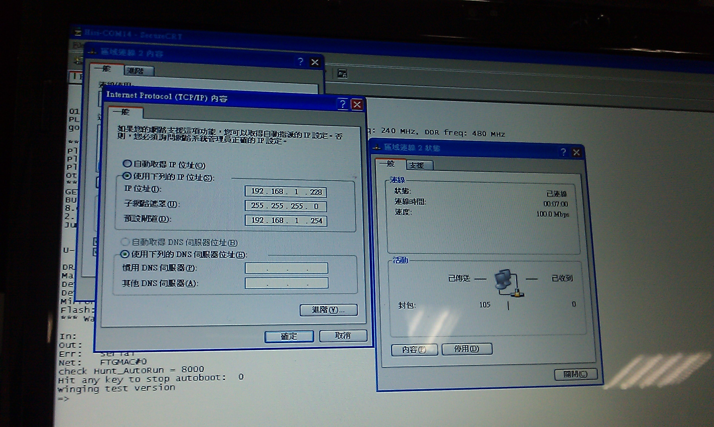
- 啟動TFTP Server
To click TFTP server


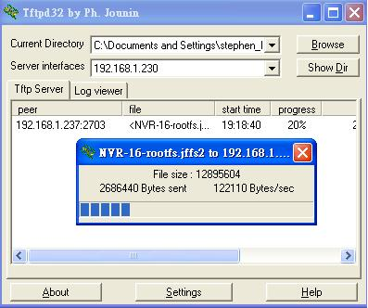

- 進入自動下載更新模式
To turn on the auto download/update mode
a..送電前，請先按住下方按鍵，再啟動電源。
a. Before turning on the Hybrid, please press the button as below, and then turn on the Hybrid
. 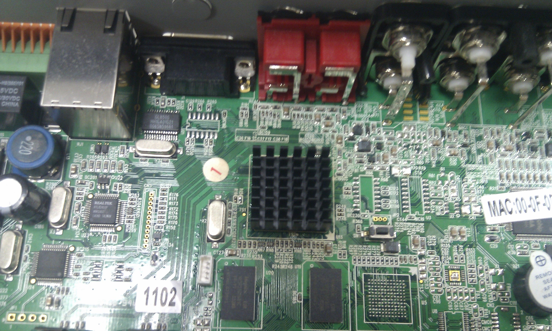

b..更新完成後會自動重開機。
b. After the update progress is done. And the Hybrid will auto reboot.

