Thermal & Optical Bi-spectrum Network Bullet Camera

SS-222 (9266)

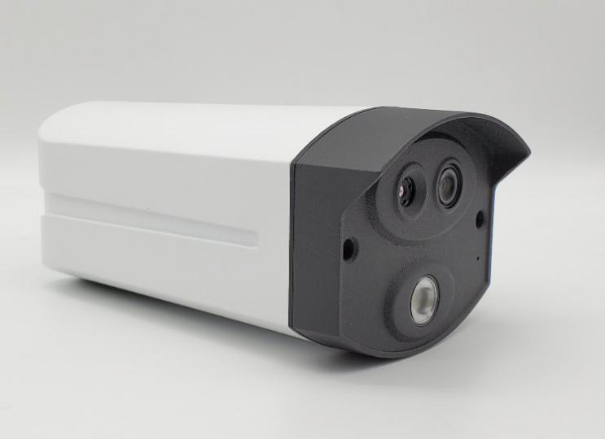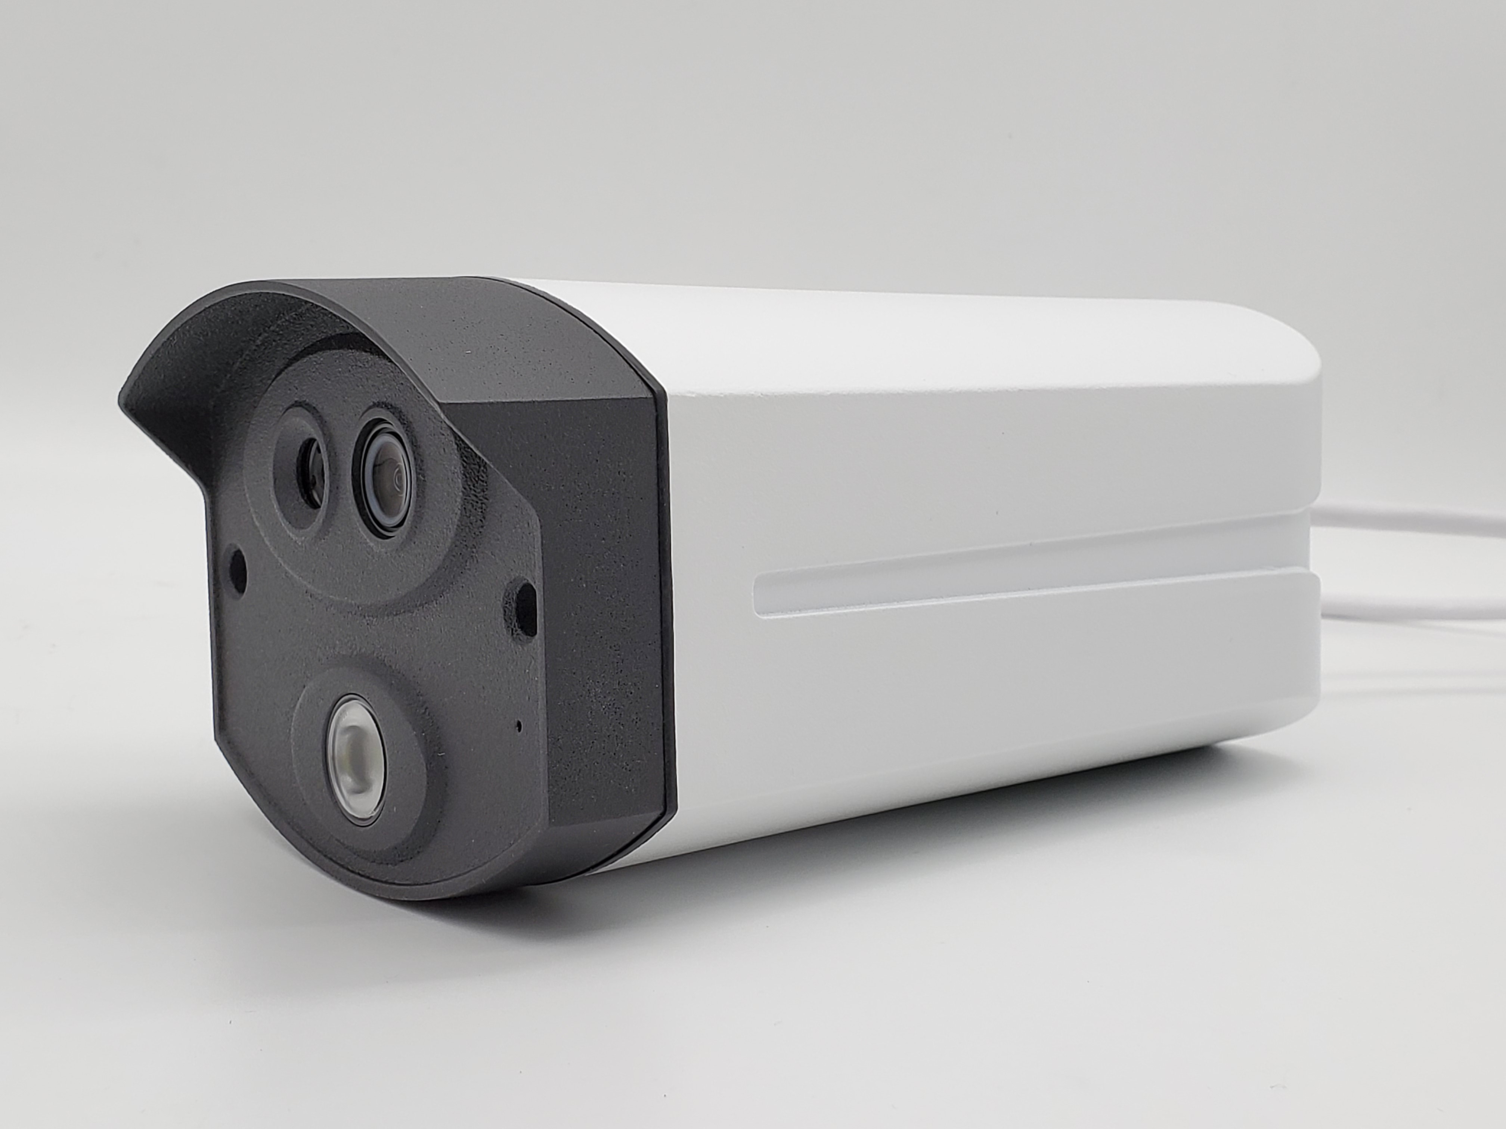

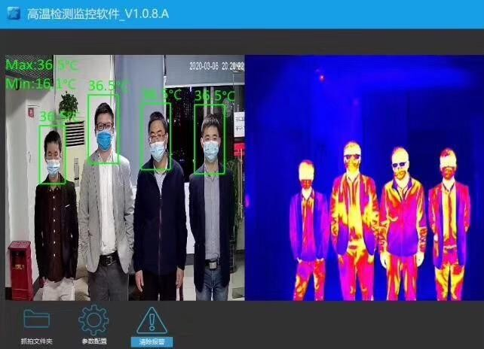

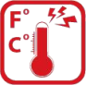





High sensitivity thermal module with 256 x 192 resolution NETD is less than 60 mk (@25° C, F#=1.0)
Supports contrast adjustment
Leading thermal image processing technology: Adaptive AGC, DDE, 3D DNR Up to 15 palettes of adjustable color
Reliable temperature-anomaly alarm Temperature Range From -15°C to +150°C High quality optical module with 2 MP resolution
Bi-spectrum image fusion, picture-in-picture preview

Specification
Thermal
Image Sensor | VOx Uncooled Focal Plane Arrays
Resolution | 256×192
Pixel Interval | 12μm
NETD | Less than 60 mK (@25°C,F#=1.1)
Aperture | F1.0
Field of View | 35° × 27° (H × V)
Optical
Image Sensor | 1/2.8" 2.0M Pixel CMOS
Resolution | 1920×1080P

Min. Illumination | Color: 0.005Lux @ (F1.2, AGC ON), B/W: 0.001 Lux @ (F1.2, AGC ON)
Field of View | 84° × 45° (H × V)
Focal Length | 4mm
Shutter Speed | 1s to 1/100,000s
White Balance | Auto/Manual/ATW (Auto-tracking White Balance)/Indoor/Outdoor/Daylight Lamp/Sodium Lamp
Day & Night | ModeIR cut filter with auto switch
WDR | 80 dB
Feature
Bi-spectrum Image Fusion | Fusion view of thermal view and overlaid details of the optical channel
Picture in Picture | Combines details of thermal and optical image PIP, overlay thermal image on optical image
Smart Function
Face snapping | Built-in deep learning AI algorithm, Supports simultaneous detection of 20-30 faces
Temperature Measurement | Support global and local temperature
Temperature Range | From -15°C to +150°C
Temperature Accuracy | Target temperature 35°C ^ 38°C ±0.3 °C  Target temperature 20°C ^ 33°C ±0.6 °C Target temperature 38°C ^ 50°C ±0.6 °C
Network
Main Stream | Thermal: 25fps(1920 × 1080, 1280 × 720)
Sub Stream | Thermal: 25fps(704 × 576, 352 × 288)
Video Compression | H.264 (Baseline/Main/High Profile) /MJPEG/H.265
Audio Compression | G .711u/G.711a/G.722.1/MP2L2/G.726/PCM
Protocols | TCP/IP, ONVIF, GB/T 28181, DHCP, RTP, RTSP, PPPoE, UPnP, UDP
API | ONVIF (Profile S, Profile G, Profile T), SDK
General
Web Client Language | languages English, Chinese
Power | DC 12V, 0.65A
Work Temperature/Humidity | From -20°C to 55°C; Humidity: 95% or Less
Protection Level | IP67
Dimension | 246 mm × 101 mm × 81 mm (with bracket)
Weight | Approx. 1.0 kg

