IPC upgrade explanation
1、Connect the camera and the computer to the same router, or link the computer and the camera (note that the computer IP address is fixed)
2、Open the search tool, refresh the list, find the device to be upgraded, and tick it (as shown below)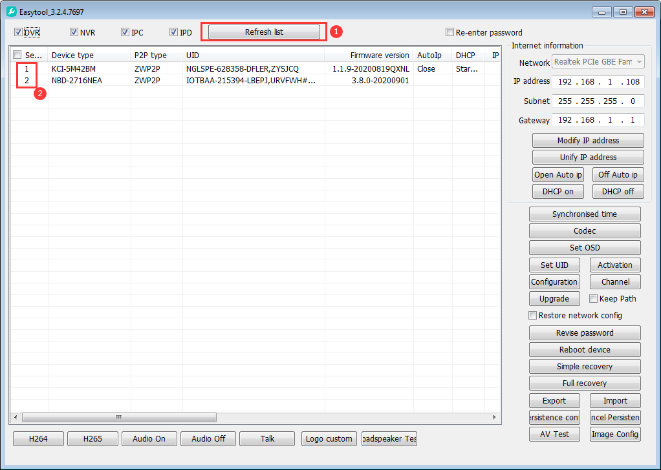
3. Select firmware upgrade, fill in the device user name and password (default user name admin, password: empty), click confirm, select the firmware to be upgraded, open it, and the device will enter the upgrade (Figure below)）
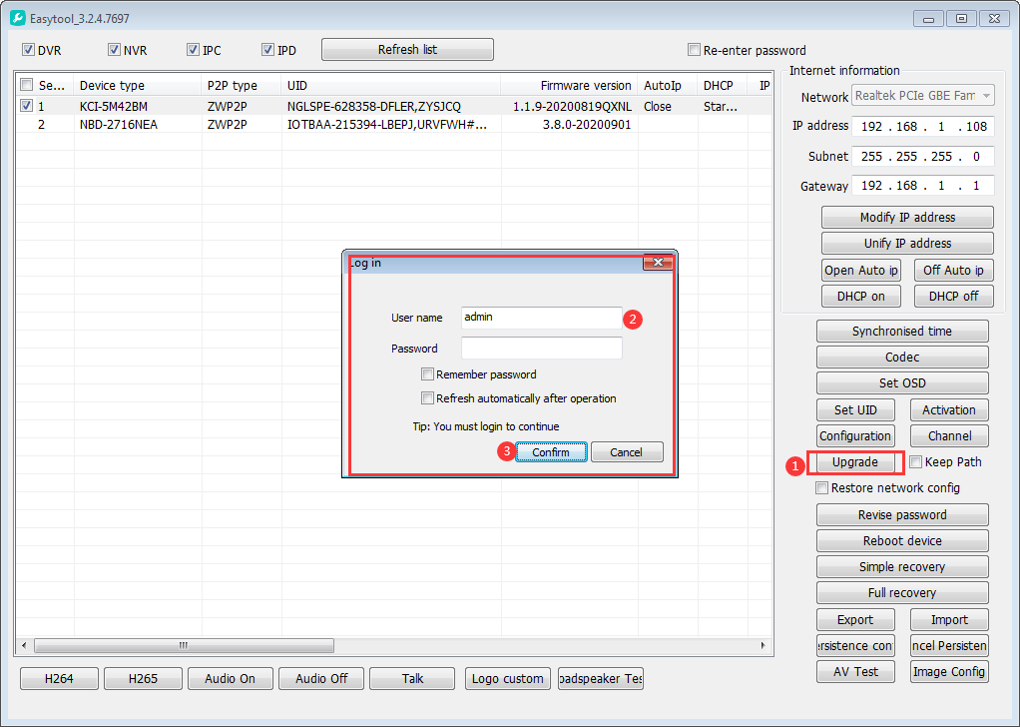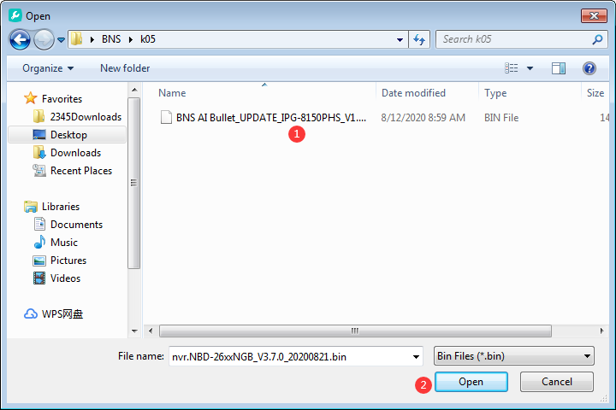
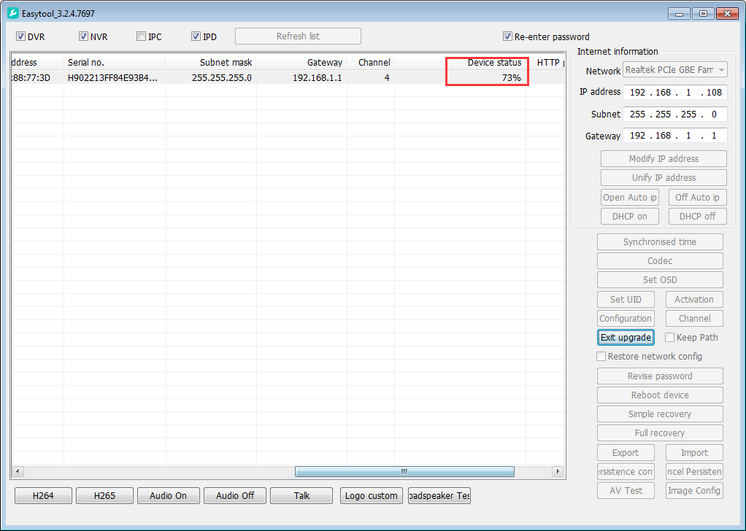

- After the upgrade is completed, the device will prompt whether the upgrade is successful or failed. After the upgrade, the device will automatically restart. After the restart, the device will be forced to reset
the device section will be used normally
