Keyboard Controller

Installation & Operation Manual

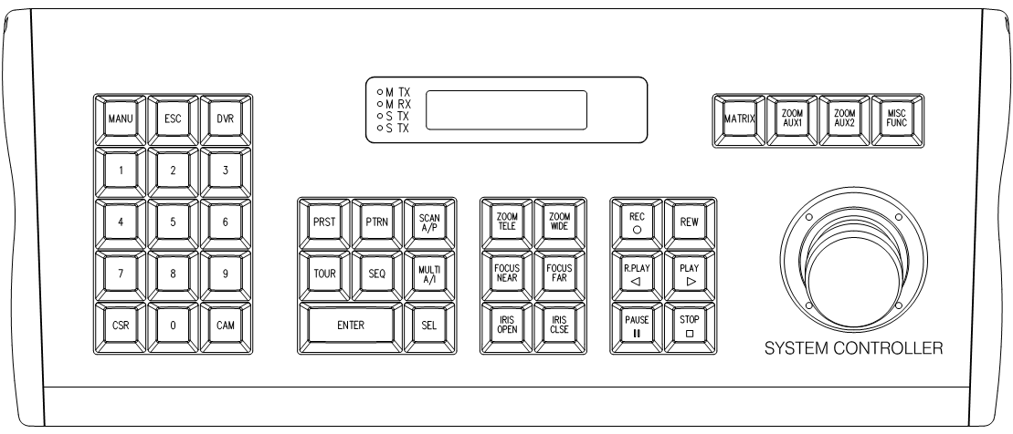

CONTENTS

What’s in the box …………………………………………………………………………………….. | 2
Warning & Caution …………………………………………………………………………………………... | 3
General descriptions…………… …………………………………………………………………… …... | 5
A. General descriptions………… ……………………………………………………………… … | 5
B. Features…………………………………………………………………………………………… …. | 5
Installation………………………………………………………… ………………………………… ……. | 6
Part names & functions……………………………………… ………………………………………… ... | 9
A. General description………………………… …………………………………………… …… | 9
B. Part names & functions (rear side) …………………………………………………… ... | 10
C. Drawing of console desk ………… ………………………………………………………... | 10
Access to the camera menu………………………………………………………………… ……... | 11
A. Display LCD window……………………………………………………………… ……………….. | 11
B. How to select address……………………………………………………………… …………. | 11
C. Easy preset save and calls………………………………………………………… ………… | 12
D. How to use tour function………………………………………………………… ………….. | 12
E. How to use pattern function……………………………………………………… ………... | 12
F. How to use scan function……………………………………………………… ……………… | 13
G. How to use AUX1…………………………………… ………………………… …………………. | 13
H. How to use AUX2……………………………………………………………………………………. | 14
I. Easy function to save and to run…………………… ………………………………… ………….. | 14
Access to the DVR menu…………………………………………………………………… ………... | 15
A. Display selection…………………………………… ……………………………… …………….. | 15
B. DVR function………………………………………………………………………… ……………… | 15
C. Matrix function ………………………………… …………………………………………………. | 16
How to use setup menu………………………………… ………………………………………………… | 18
Example of camera/DVR setting & operation … …………………………………………………. | 21
Specification …………………………………………………………………………………………………... | 23
Dimension………………………………………………………………………………………………………... | 23

What’s in the box ?

- Controller
- Junction Box
- RJ11 8Pin Modular Cable 1EA
- Manual

-2-

WARNING & CAUTION

WARNING
TO REDUCE THE RISK OF FIRE OR ELECTIC SHOCK, DO NOT EXPOSE THIS PRODUCT TO RAIN
OR MOISTURE. DO NOT INSERT ANY METALLIC OBJECTS THROUGH THE VENTILATION GRILLS OR OTHER OPENINGS ON THE EQUIPMENT

CAUTION

CAUTION
RISK OF ELECTRIC SHOCK
DO NOT OPEN

CAUTION: TO REDUCE THE RISK OF ELECTRIC SHOCK,
DO NOT REMOVE COVER(OR BACK).
NO USER-SERVICEABLE PARTS IN SIDE.
REFER SERVICING TO QUALIFILED SERVICE PERSONNEL.

GRAPHICAL SYMBOL EXPLANATION

The Lightning flash with arrowhead symbol, within an equilateral triangle, is
Intended to alert the user to the presence of un-insulated “dangerous voltage”
Whit in the product’s enclosure that may be of sufficient magnitude to
Constitute a risk of electric shock to persons.

!

The exclamation point within an equilateral triangle is intended to alert the
User to the presence of important operating and maintenance (servicing)
instructions in the literature accompanying the product.

- 3 -

FCC COMPLIANCE STATEMNET
INFORMATION TO THE USER : THIS EQUIOMENT HAS BEEN TESTED AND FOUND
TO COMPLY WITH THE LIMITS FOR A CLASS A DIGITAL DEVICE. PURSUANT TO
PART 15 OF THE FCC RULES, THESE LIMITS ARE DESIGENED TO PROVIDE
REASONABLE PROTECTION AGAINST HARMFUL INTERFERENCE WHEN THE
EQUIPMENT IS OPERATED IN A COMMERCIAL ENVIRONMENT. THIS EQUIPMENT
GENERATES. USERS. AND CAN RADIATE RADIO PREQUENCY ENERGY AND IF
NOT INSTALLED AND USED IN ACCORDANCE WITH THE INSTRUCTION MANUAL
MAY CAUSE HARMFUL INTERFERENCE TO RADIO COMMUNICATIONS.
OPERATION OF THIS EQUIPMENT IN A RESIDENTIAL AREA IS LIKELY TO CAUSE
HARMFUL INTERFERENCE IN WHICH CASE THE USER WILL BE REQUIRED TO
CORRECT THE INTERFERENCE AT HIS OWN EXPENSE.

CAUTION : CHANGES OR MODIFICATIONS NOT EXPRESSLY APPROVED BY THE
PARTY RESPONSIBLE FOR COMPLIANCE COULD VOID THE USER’S AUTORITY TO
OPERATE THE EQUIPMENT

CE COMPLIANCE STATMENT

THIS IS A CLASS A PRODUCT. IN A DOMESTIC ENVIRONMENT THIS PRODUCT MAY
CAUSE RADIO INTERFERENCE IN WHICH CASE THE USER MAY BE REQUIRED TO
TAKE ADEQUATE MEASURES.

- 4 -

GENERAL DESCRIPTIONS

GENERAL DESCRIPTIONS
* Operator Control keypad is DVR & Camera controller and it allows how to operate the functions easily.
* This keypad controls DVR and Camera such as DVR setup, Playback, PTZ function.
* The LCD shows display current status as well as provides a menu to set up operational parameters.
* This keypad is designed for desktop operation and interface connectors are located in the junction box.

FEATURES
* To control all DVR functions such as Live display, Playback, DVR Setup, PTZ and Matrix.
* To control up to 255 DVRs from one keyboard controller.
* To control up to 255 cameras from one keyboard controller.
* Multi-protocol supported ( PELCO-D, VICON ).
* Preset position control.
* Maximum speed can be changed according to zoom ratio.
* To recall the programmed auto-scan from selected dome camera
* Built in LCD Display with blue screen.
* User password and system hold function

- 5 -

INSTALLATION

Open the box and check if all below items are included in the box.
. keyboard controller…………...……… 1
. Junction box …………………….……. 1
. 8P RJ45 Modular Cable (2m) ……… 1

1. Jumper setting
2. Junction box
3. Junction box data In/Out port (To Keypad)
4. Keyboard data In/Out port (To Junction Box)
5. Master RS485 D+/D- (To CAM1, CAM2 )
6. Slave RS485 D-/D+ (To DVR)

- 6 -

INSTALLATION

A. Single DVR configuration
- Connect RJ45 to the rear of keyboard controller and data on the junction box and plug in
DC12V power to DC jack.
- Connect CAM1 or CAM2 (RS485(D+),RS485(D-)) to Junction box terminal and
communication Jack on PTZ camera (Please make sure of polarity)
3. Turn on the power and then you will be on the starting mode
4. Connect DVR (RS485(D+),RS485(D-)) to the Junction box terminal and the RS-485 A port of DVR. Please make sure of the polarity.
5. Connect Daisy-out port of DVR to the Monitor.

< Example of using single DVR Configuration >

- 7 -

INSTALLATION

B. Multiple DVR configuration
- Connect RJ45 to the rear of keyboard controller and data on the junction box and plug in
DC12V power to DC jack.
- Connect CAM1 or CAM2 (RS485(D+),RS485(D-)) to Junction box terminal and
communication Jack on PTZ camera (Please make sure of polarity)
3. Turn on the power and then you will be on the starting mode
4. Connect the DVR (RS485(D+),RS485(D-)) to Junction box terminal and the RS-485 A port of DVRs. Please make sure of polarity.
5. Connect Daisy-out port to DVR that DVR_ID number is 1 and connect Daisy-In port to DVR that DVR_ID number is 2
6. Connect Daisy-out port of the last DVR to the Monitor

< Example of using multiple DVRs Configuration >

- 8 -

PART NAME & FUNCTIONS

- PART NAME & FUNCTION
4 5 6 9 10 33 11 19 1 17 18 25 23 24 29 30 31 32
7 8 12 15 13 16 14 21 22 20 27 28 26
2
3

1. LCD Display : Displays numeric input system status, function status, general status, etc…  2. Telemetry joystick : Allows precise setting mode control of Pan/Tilt/Zoom & Moving to menu  3. 0~9: : Numeric Key  4. Menu : Used for Camera(PTZ camera) and DVR menu adjustment  5. ESC: Closes the current work and goes to starting menu  6. DVR: Selects address of DVR(Up to 255)  7. CLR: Cancels Key  8. CAM: Selects address of camera  9. PRST: Save and calls camera presets and positions  10. PTRN: Runs to camera Pattern key  11. SCAN/A/P: Runs to scan or Auto Pan key  12. TOUR: Runs to camera Tour key  13. SEQ: Sequential view under live mode of DVR.  14. MULTI/A/I: Selection button for Screen Division of DVR or Camera Auto Iris key  15. ENTER: Enter key | 16. SEL: Selects Key(DVR and Key Board setting mode)  17. ZOOM TELE: Camera Zoom Control for Tele  18. ZOOM WIDE: Camera Zoom Control for Wide  19. FOCUS NEAR: Camera focus Control for Near  20. FOCUS FAR: Camera focus Control for Far  21. IRIS OPEN: Camera Iris Control for Open  22. IRIS CLOSE: Camera Iris Control for Close  23. REC: DVR Record Key  24. SEARCH: DVR Search Key  25. R.PLAY: DVR Reverse Play key  26. PLAY: DVR Play key  27. PAUSE: DVR Pause key  28. STOP: DVR Stop key  29. MATRIX: Matrix Function key  30. ZOOM/AUX1: DVR Zoom key or Camera Aux1 key  31. FRZ/AUX2: DVR Freeze key or Camera Aux2 key  32. MISC/FUNC: DVR Miscellaneous key or Camera Function key  33. LED: TX/RX Status View

- 9 -

PART NAME & FUNCTION

- PART NAME & FUNCTIONS(REAR SIDE)

ⓐ

DATA

ⓐ Data out port (Connector to communication and power)

- DRAWING OF CONSOLE DESK

30mm
90mm
365mm
30mm
155mm

- 10 -

ACCESS TO THE CAMERA MENU

This function is only for the PTZ camera

DISPLAY LCD WINDOW
A. Initial display
1 2 3

1. Show the selected unit (Camera or DVR)
Cam: 001 2400 BPS
Standby…

2. Show the selected unit address No. (001 ~ 255)
3. Show the selected baud rate (2400/4800/9600 bps)
4. Show the controller status
4

B. How to select address
B-1. How to select address number 1 or 2 of camera.
1
Cam: 001 2400 BPS
Standby…

CAM
or
2
Cam: 001 2400 BPS
Standby…

Up to 255

B-2. How to select address number 1 or 2 of DVR
1
Dvr: 001 9600 BPS
Standby…

DVR
or
2
Dvr: 001 9600 BPS
Standby…

Up to 255
- 11 -

ACCESS TO THE CAMERA MENU

C. Easy preset save and calls ( in case of cam 1 / 2400 bps )
C-1. How to save preset 1 or 2 (1~64, 100~200)
After pushing no. 1 or 2, hold PRST for about 2 seconds

1
2
PRST
Cam: 001 2400 BPS
➔ 001 Preset Save
or

C-2. After pushing no. 1 or 2, push PRST shortly, it makes PRST work.
2
1
PRST
Cam: 001 2400 BPS
➔ 001 Preset

or

D. How to use TOUR function
D-1. Using VICON protocol (in case of Cam1/4800 bps )
1. Tour should be set using camera setup Menu.
2. Generally, Vicon tour function is working using specific preset number.( 80 ~ 87 )
3. After camera tour setup, you can operate tour function calling preset number.
8
0
PRST
Cam: 001 4800 BPS
➔080 Preset

Up to 87

D-2. Using Pelco-D protocol (in case of Cam1/2400 bps )
1. Tour should be set using camera setup Menu.
2. pushing no. 1 or 2, push TOUR shortly, it makes TOUR work.
1
2
TOUR
Cam: 001 2400 BPS
➔001 Tour
or

Up to 8

- 12 -

ACCESS TO THE CAMERA MENU

E. How to use PATTERN function
E-1. Using VICON protocol (in case of Cam1/4800 bps )
1. Pattern should be set using camera setup Menu.
2. Generally, Vicon pattern function is working using specific preset number.( 88 ~ 89 )
3. After camera pattern setup, you can operate pattern function calling preset number.
8
8
PRST
Cam: 001 4800 BPS
➔088 Preset

Up to 89

E-2. Using Pelco-D protocol (in case of Cam1/2400 bps )
1. Pattern should be set using camera setup Menu.
2. pushing no. 1 or 2, push PTRN shortly, it makes PTRN work.
1
2
PTRN
Cam: 001 2400 BPS
➔001 Pattern
or

Up to 8

F. How to use SCAN function
F-1. How to use auto scan.
SCAN
A/P
Cam: 001 2400 BPS
➔ Scan

G. How to use AUX1 function
G-1. How to use AUX1.
ZOOM
AUX1
Cam: 001 2400 BPS
➔ Aux1

- 13 -

ACCESS TO THE DVR MENU

H. How to use AUX2 function
H-1. How to use AUX2.
FRZ
AUX2
Cam: 001 2400 BPS
➔ Aux2

I. Easy Function saves and runs (In case of cam 1 / 2400 BPS)
Function key is useful when you use lots of camera. Generally each camera has been programmed preset positions. If you want to see each camera’s specific preset position, first you have to select camera and then you should select preset number. It is inconvenient. Function key save camera number and preset number.
I-1. How to save function (1~999)
Supposing that you save preset 1 of camera 1 at function1, first you should operate preset 1 of camera 1.
1
PRST
Cam: 001 2400 BPS
➔ 001 Preset

After that push number 1 and hold FUNC key for about 2 seconds.
1
MISC
FUNC
Cam: 001 2400 BPS
➔ 001FSave Pst033

Up to 999

I-2. How to run function (1~999)
After pushing no. 1, push FUNC key shortly, it makes FUNC work.
1
MISC
FUNC
Cam: 001 2400 BPS
➔ 001FRun Pst001

Up to 999

- 14 -

ACCESS TO THE DVR MENU

A. Display Selection ( in case of DVR 1 / 9600 bps )
A-1. How to use channel sequence
Sequential view under live mode : Viewing of all active video input channels sequentially at selected DVR
SEQ
Dvr: 001 9600 BPS
➔ SEQUENCE

A-2. How to use single channel display
After pushing channel number ‘n’(1~16), push ENTER, then the selected channel displays.
Exceptionally, ‘0’ + ‘ENTER’ works same as ‘MULTI’
n
ENTER
Dvr: 001 9600 BPS
Standby…

A-3. How to use multi channel display
Live mode : Selection of Screen Division for Live Viewing mode(4,8,9,16 screen divisions)
Playback mode : Selection of Screen Division for playback. It shows 4,9,16 divided screen.
It works same as MULTI key of DVR.
MULTI
A/I
Dvr: 001 9600 BPS
➔ MULTI

B. DVR Function ( in case of DVR 1 / 9600 bps )
B-1. How to use REC button
Press once to begin recording all active channels. Press again to end recording.
REC
●
Dvr: 001 9600 BPS
➔ RECORD

B-2. How to use SEARCH button
Press once to open the menu to search for recorded files.
SEARCH
Dvr: 001 9600 BPS
➔ SEARCH

- 15 -

ACCESS TO THE DVR MENU

B-3. How to use R.PLAY button
Press once to open the menu to search for recorded files. Under PTZ control menu, used to decrease the speed of Pan Tilt, Zoom, Focus.
R.PLAY
◀
Dvr: 001 9600 BPS
➔ R.PLAY

B-4. How to use PLAY button
Playback button will activate assigned starting position and channel at playback setup of a selected DVR menu. Under PTZ control menu, used to increase the speed of Pan, Tilt, Zoom, Focus.
PLAY
▶
Dvr: 001 9600 BPS
➔ PLAY

B-5. How to use PAUSE button
Press once to freeze playback. Press again to restart playback.
PAUSE
▐ ▌
Dvr: 001 9600 BPS
➔ PAUSE

B-6. How to use STOP button
Press once to stop playback.
STOP
■
Dvr: 001 9600 BPS
➔ STOP

B-7. How to use ZOOM button
Zoom In/Out on the images during Live Viewing.
ZOOM
AUX1
Dvr: 001 9600 BPS
➔ ZOOM

- 16 -

ACCESS TO THE DVR MENU

B-8. How to use FRZ button
Press button once to freeze the frame at live mode. Press again to return.
FRZ
AUX2
Dvr: 001 9600 BPS
➔ FREEZE

B-9. How to use MISC button
To substitute for the buttons that are placed on the remote control but that are not placed on the keyboard (NET, OSD, Audio Mute, HDD, LOG). (If the button is pressed, windows appear, and user can select lower menu one by one).
MISC
FUNC

Dvr: 001 9600 BPS
➔ MISC

C. Matrix function
C-1. How to use Matrix button
After pushing no. n, push Matrix shortly, keypad mode is changed into Cam mode and it waits camera control command. Daisy chain output displays n channel camera image.
n channel camera is calculated by below formula.
* n = (DVR_ID-1)*16 + camera channel number, DVR ID = 1 ~ 255
n
MATRIX
Cam: n 2400 BPS
Standby…

Ex) Three sets of 16channel DVRs are installed. You want to control the third camera of second DVR. In this case, n is calculated (2(DVR_ID)-1)*16 + 3(CAMERA CHANNEL) = 19
Daisy chain output displays the third camera of second DVR.
19
MATRIX
Cam: 019 2400 BPS
Standby…

- 17 -

HOW TO USE KEYBOARD CONTROLLER SETUP MENU

When you change the setting value of setup menu, you should enter “9. Save And Exit”
How to go to setup menu : After pushing no. key 11, SEL key for over 3 seconds
1
1
SEL

A. How to use setup menu
A-1. As you move joystick up and down, you can go to next menu, move left and right,
you can change the value of setting.

A-2. Starting display in setup menu.
1. Baud Rate #1
Master 2400 BPS

A-3. How to set the Master Baud Rate
( You can change the value of Master baud rate by moving Joystick Left and Right)
1. Baud Rate #1
Master 2400 BPS

1. Baud Rate #1
Master 4800 BPS

1. Baud Rate #1
Master 9600 BPS

A-4. How to change Slave Baud Rate
( You can change the value of Slave baud rate by moving Joystick Left and Right)
2. Baud Rate #2
Slave 2400 BPS

2. Baud Rate #2
Slave 4800 BPS

2. Baud Rate #2
Slave 9600 BPS

A-5. How to change Protocol
(You can change the Protocol by moving Joystick Left and Right)
* TPro201 includes Pelco-D, so when you need to use Pelco-D, you can use TPro201.
3. Protocol
TPro201

3. Protocol
VICON

- 18 -

HOW TO USE KEYBOARD CONTROLLER SETUP MENU

A-6. How to use System Lock function
You can use 0~999 by no. key,
when you input 000. it is OFF, when you input 001~999, Lock mode works
* Lock mode will be active, when keypad and joystick are not used for the set time.
4. System Lock
OFF
4. System Lock
1~999
or

A-7. How to enter Password
-. You can choose 0 up to 999 and push enter key
-. When you forget the password, please call to the vendors that you purchased from.
1
ENTER
5. Password
[ * * * ] * * *

Up to999
1
ENTER
5. Password
* * * [* * *]

Up to 999

A-8. Beep
How to set beep.
-. You can change the beep On/Off by moving Joystick Left and Right
6. Beep
ON
6. Beep
OFF

A-9. Function Use
-. You can choose whether use or not the FUNC key.
Function Key is useful when you control several cameras. You can save camera ID & preset number at the specific function number.(1~999)
7. Function Use
Use
7. Function Use
UnUse

- 19 -

HOW TO USE KEYBOARD CONTROLLER SETUP MENU

A-9. LCD Backlight
How to set up LCD Backlight.
-. You can change the Always ON, After 10sec, After 20sec, After 30sec, After 60sec by moving Joystick Left and Right
8. LCD Backlight
Always ON

A-10. How to save and exit by Joystick Left and Right
9. Save And Exit

A-11. Exit
10. Exit

- 20 -

EXAMPLES OF CAMERA/DVR SETTING & OPRERATION

A. DVR Menu setting
A-1. Menu → Camera Setup → PTZ Setup
Model No : PELCO-D or VICON
PTZ ID : 0~255 (In case of “0”, it is normally not used)
Baud Rate: 9600
A-2. Menu → System Setup → DVR ID
DVR ID : 0 ~ 255(In case of “0”, it is normally not used)

B. Keyboard setting (No need to change it because it is set as the default)
B-1. Enter Setting mode : “1” +”1”+ ”SEL” (Push “SEL” button in 3 seconds)
B-2. Camera control Baud rate :
1. Baud rate #1 : Master 2400 (in case protocol is TPro201)
1. Baud rate #1 : Master 4800 (in case protocol is VICON)
B-3. DVR control Baud rate : 2. Baud rate #2 : Slave 9600
B-4. Protocol : 3. Protocol : TPro 201 (Same as PELCO-D), VICON
B-5. Exit after saving the setting value : 9. Save and Exit

C. Keyboard operation
There is DVR mode and Camera model on Keypad.
Change DVR mode : DVR ID + “DVR” button
Change Camera mode: CAMERA ID + “CAM” button or CAMERA ID + “MATRIX” button
C-1. How to operate DVR
1. Select DVR : “ 1 ”(DVR ID) + “ DVR ” button
2. Example to operate
2.1 Menu setting screen On/Off : “ Menu ” button
2.2 Change Live screen : “ 1~16 “ + “ Enter “, “ 0 “ + “ Enter “, “Multi”
2.3 Playback start : “ Play ” button

- 21 –

EXAMPLES OF CAMERA/DVR SETTING & OPRERATION

C-2. How to operate camera
1. Select camera : “ 1 ”(Camera ID) + “ CAM ” button
2. Example to operate
2.1 Zoom Tele : “ ZOOM TELE ” button
2.2 IRIS open : “ IRIS OPEN ” button
3. Camera control command button : MENU, ZOOM TELE, ZOOM WIDE, FOCUS NEAR, FOCUS FAR, IRIS OPEN, IRIS CLSE, PRST, PTRN, TOUR, SCAN, FUNC, AUX1, AUX2, JOYSTICK

C-3. How to operate Matrix function (When connect a lot of DVRs by using Daisy chain cable)
1. How to connect and how to set DVR, Daisy chain cable, Speed dome camera
1.1 Plug in optional Daisy chain cable into extension port on No.1, No.2 DVR
1.2 Connect Daisy chain cable Vd_out on No.1 DVR into Daisy chain cable Vd_in on No.2 DVR.
1.3 Connect Daisy chain cable Vd_out on No.2 DVR into monitor (Matrix output screen)
1.4 Set “1” on No.1 DVR ID and set “2” on No.2 DVR ID.
1.5 Set “1~16” on No.1 DVR that is connected with Speed Dome camera ID and set 17~32 on No.2 DVR that is connect with Speed Dome Camera ID.
2. Example to operate
2.1 Select No.19 Camera: “ 19 ” + “ MATRIX ” button
Watch No.3 camera screen of No.2 DVR on Matrix output screen. In this case, the camera
controls command can be operated because the keypad is on the camera
mode.

- 22 -

SPECIFICATION

Item |  | Keyboard controller
Communication |  | MASTER(for CAM) : RS-485 (2400bps, 4800bps, 9600bps)  SLAVE(for DVR) : RS-485 (2400bps, 4800bps, 9600bps)
Joystick | Axis | 3-Axis, Zoom IN/OUT available
Joystick | Power Consumption | DC 12V, 110mA
Display Type |  | 16 x 2 Character LCD, With Blue Backlight
Key Type |  | PC Key board Button
Key board Connector Type |  | RJ45 8 Pin Modular Cable
Junction Box Connector |  | Master : Terminal Block. Slave : Terminal Block
Humidity |  | 10% ~ 70% non Condensing
Dimension |  | 140(W) x 185(H) x 365(D)
Weight |  | 1.2kg

DIMENSION
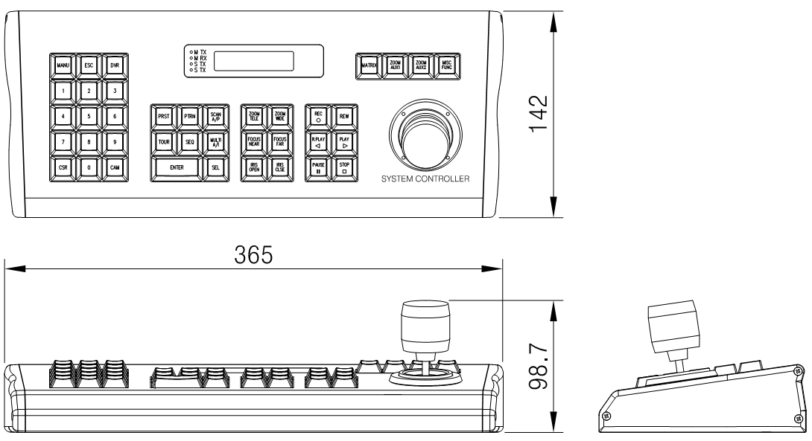
- 23 -
Nov. 2008.
Rev 1.0

